<https://www.tutorialsteacher.com/webapi/web-api-tutorials>

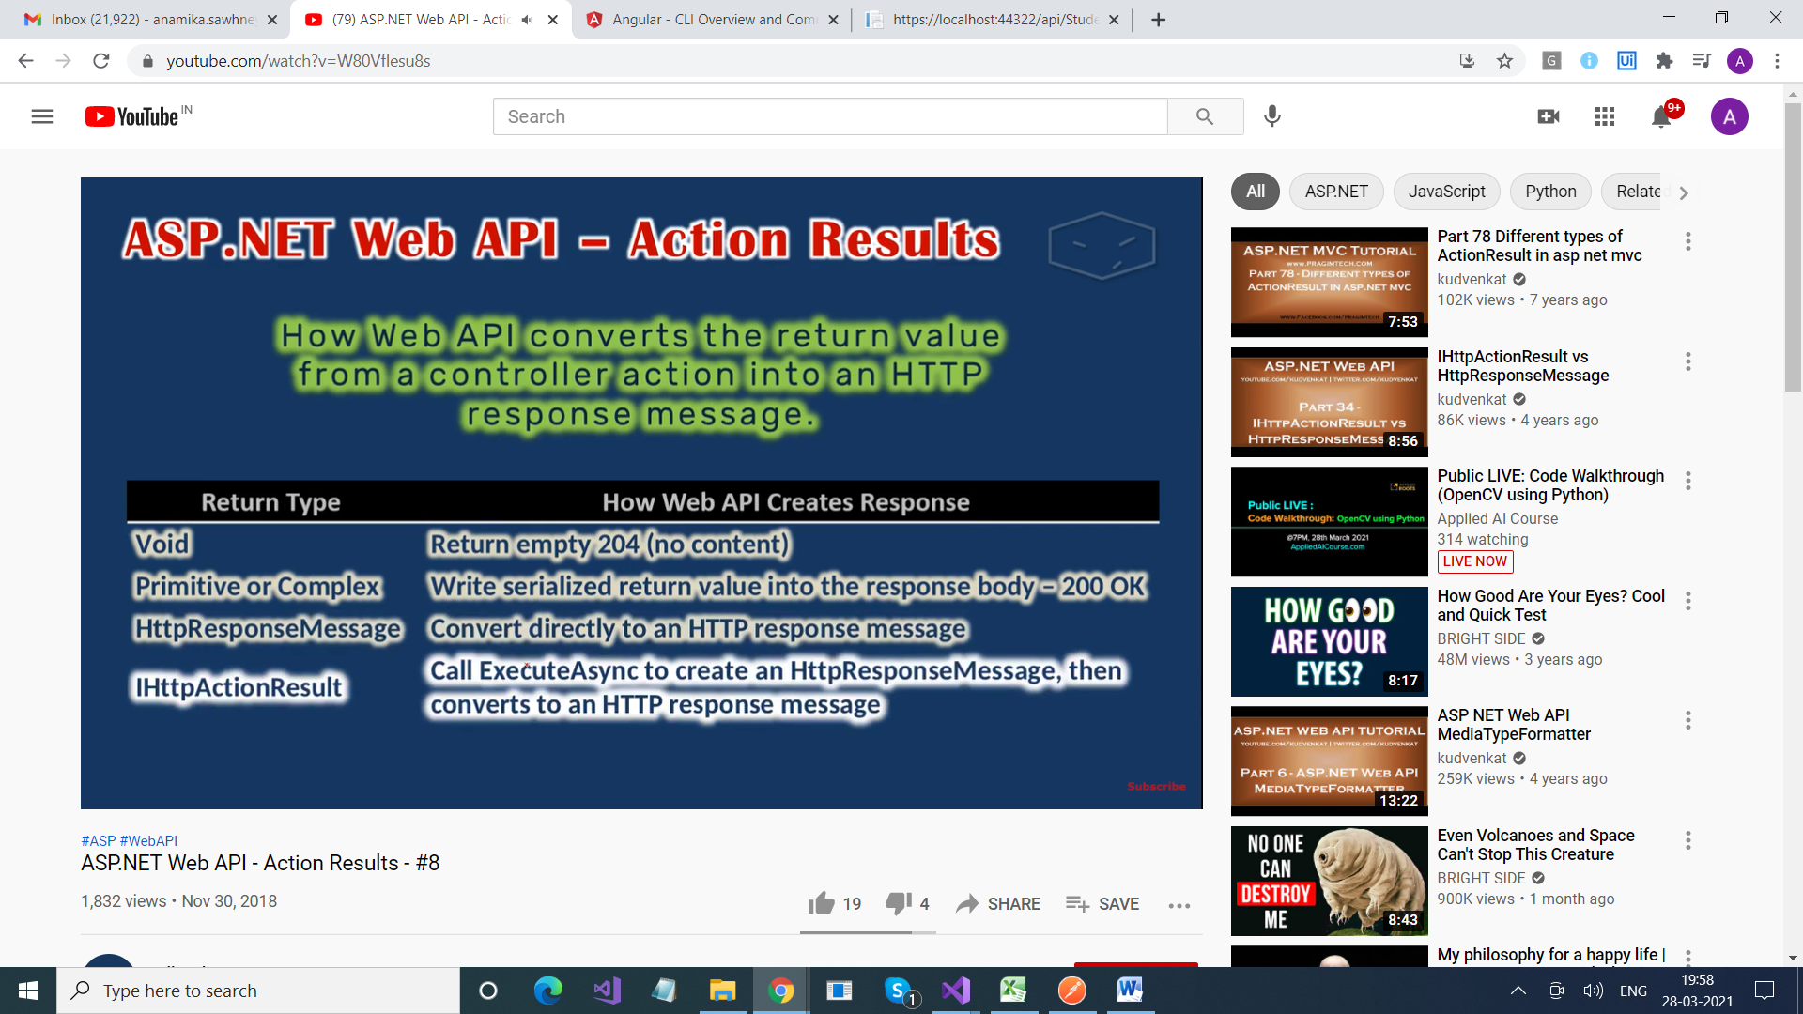

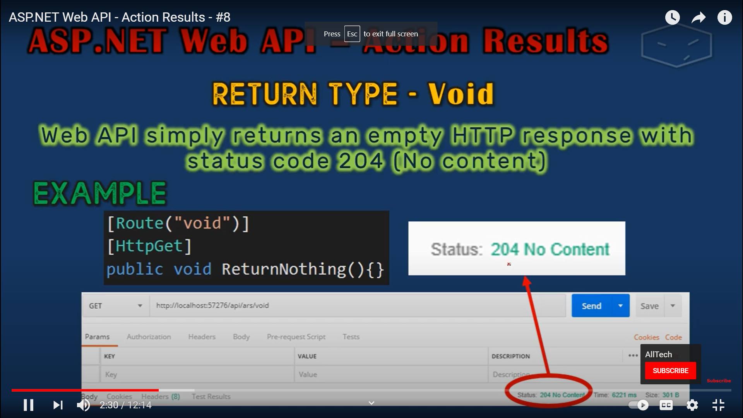

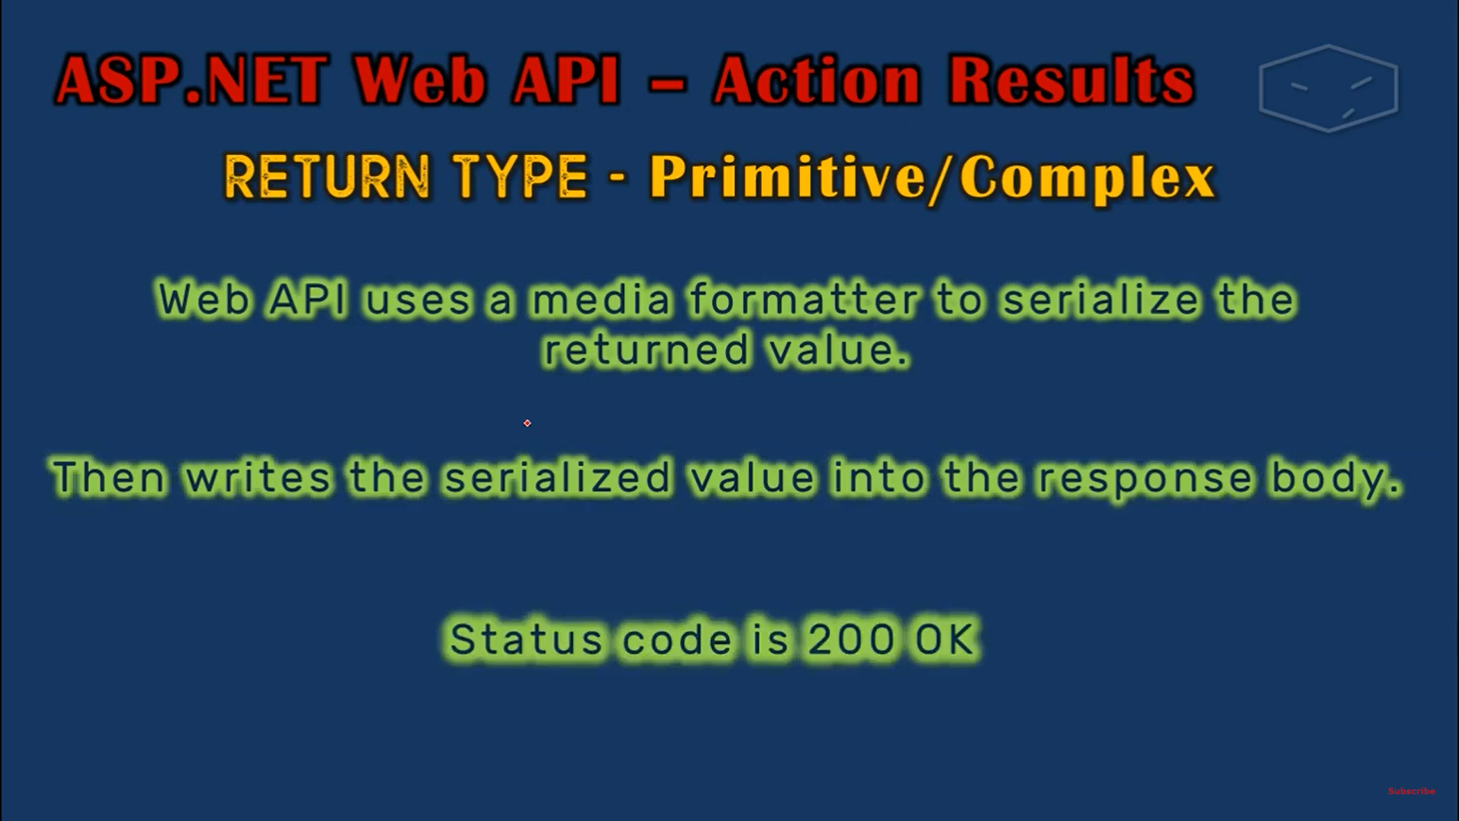

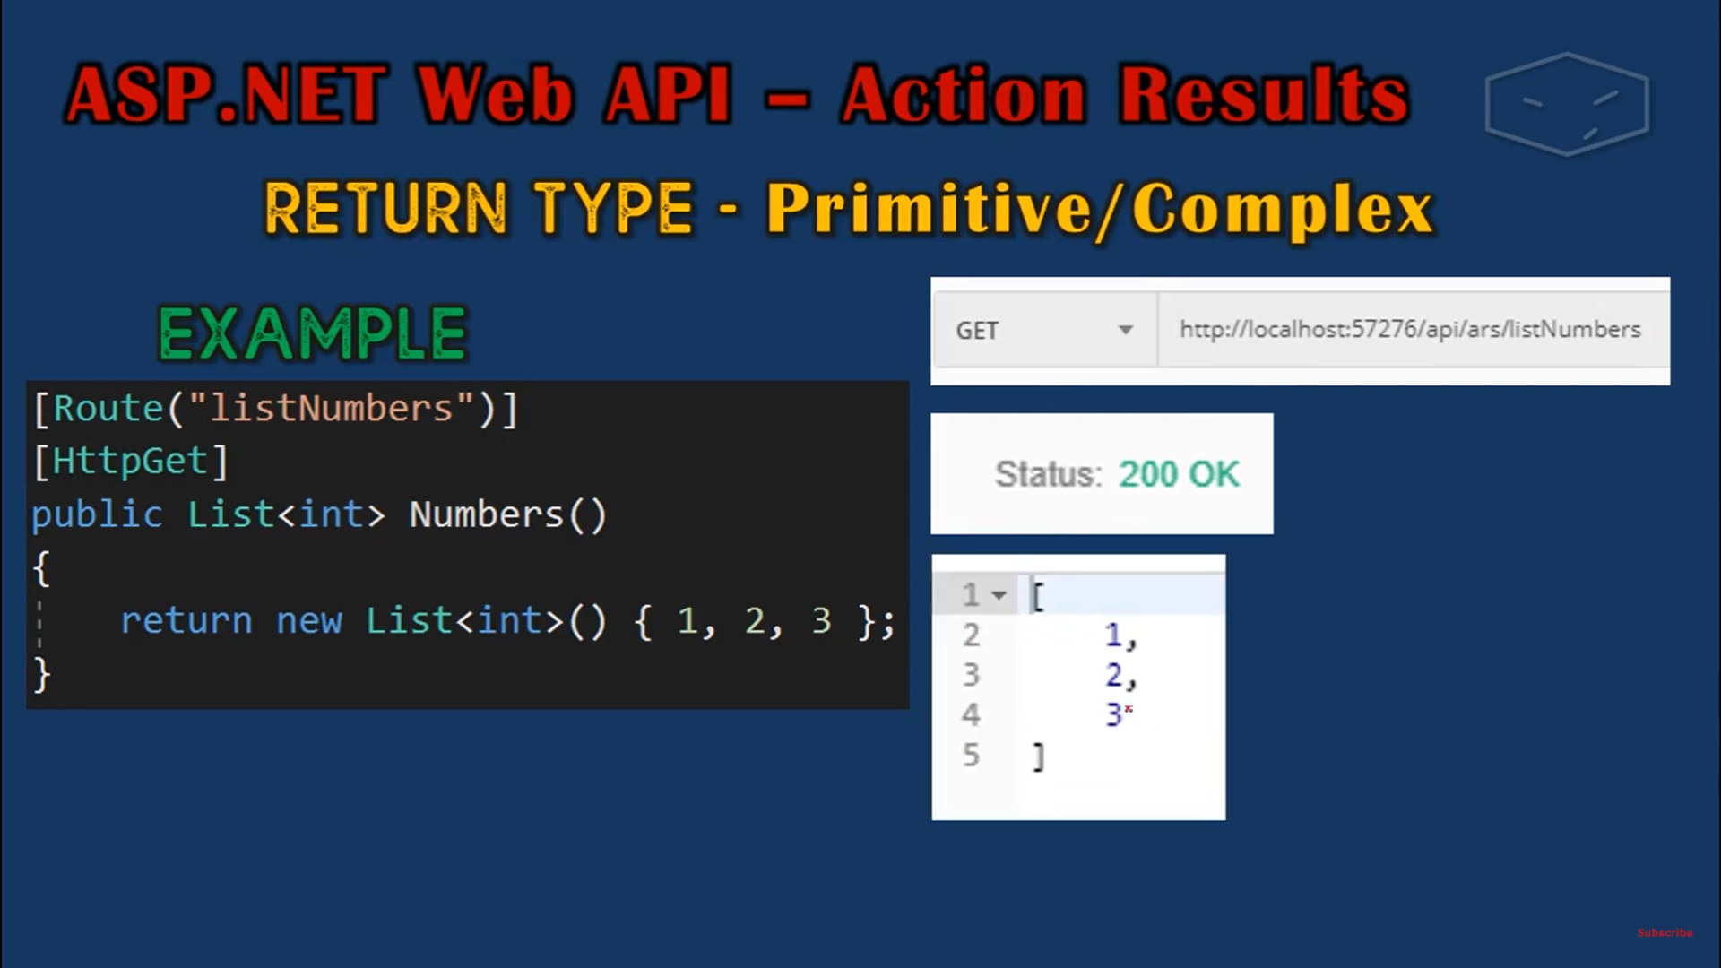

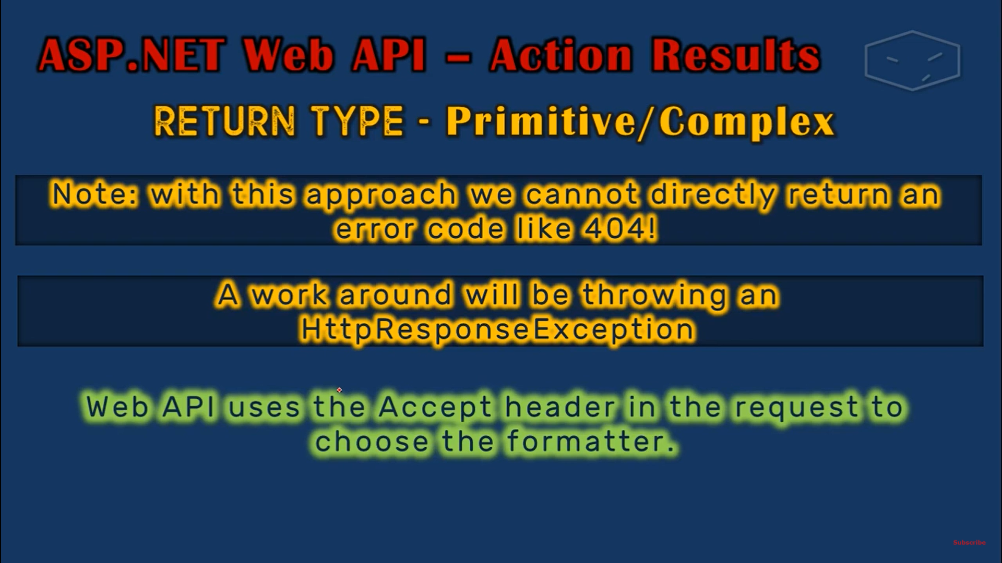

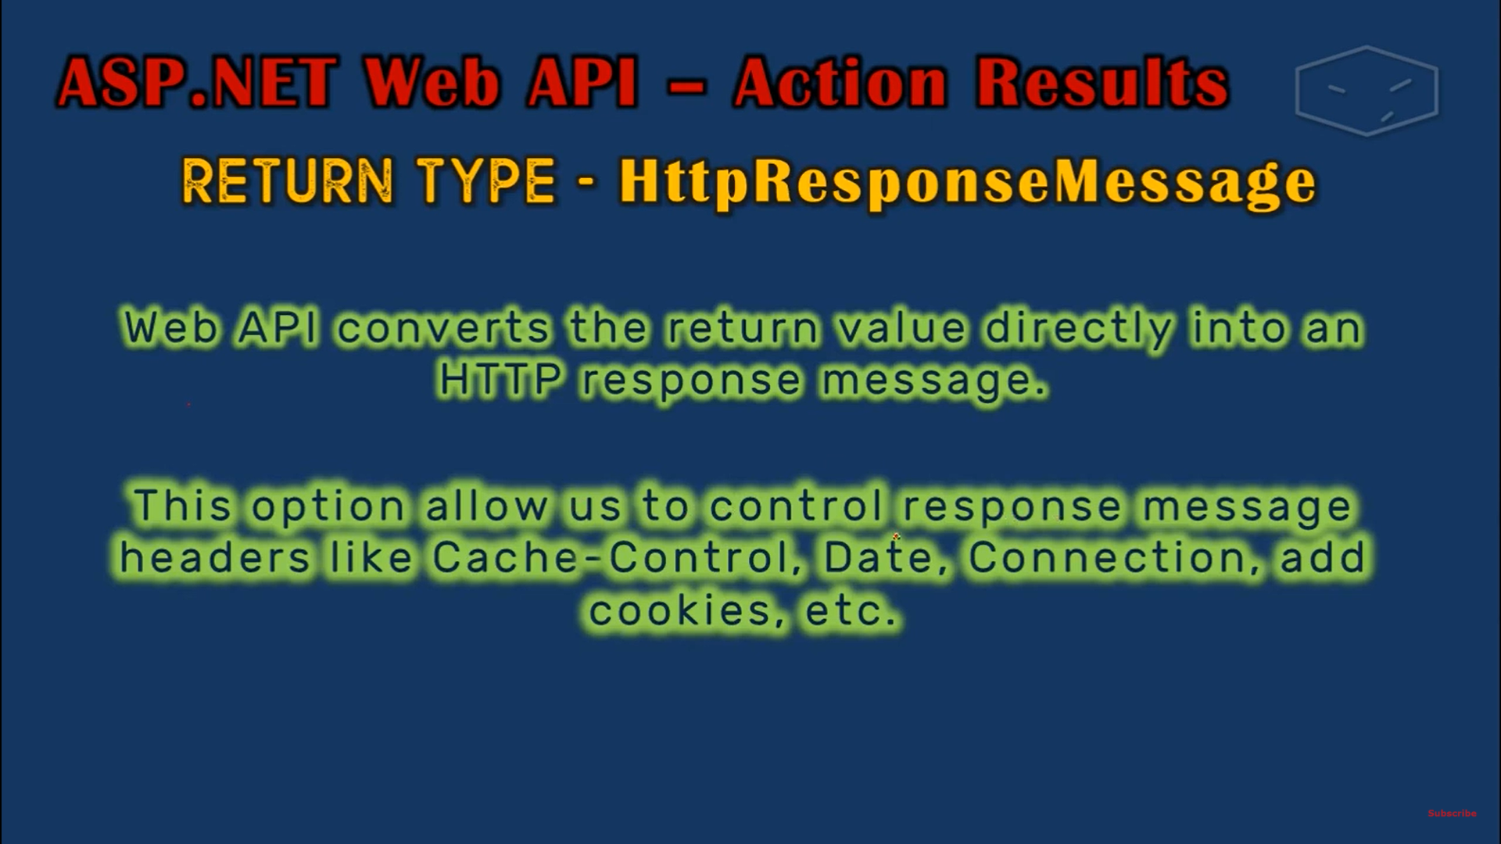

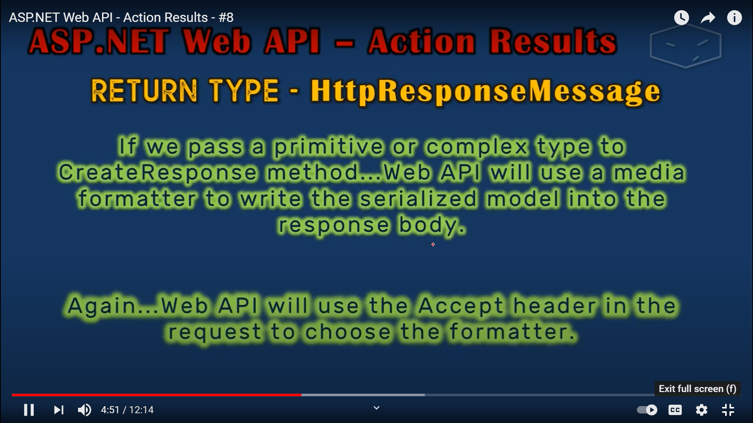

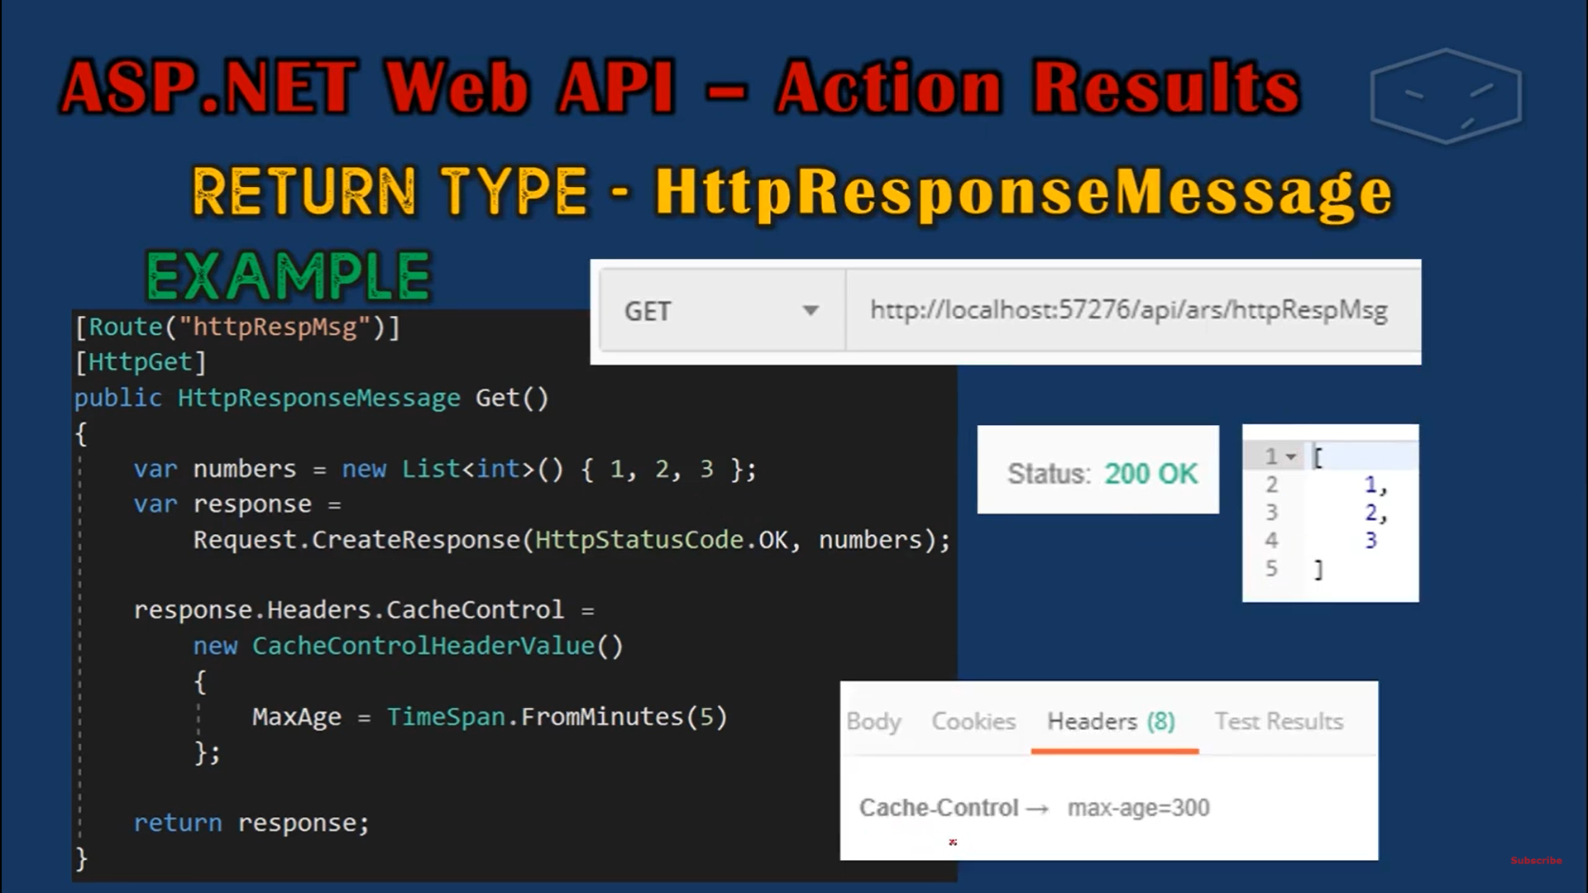

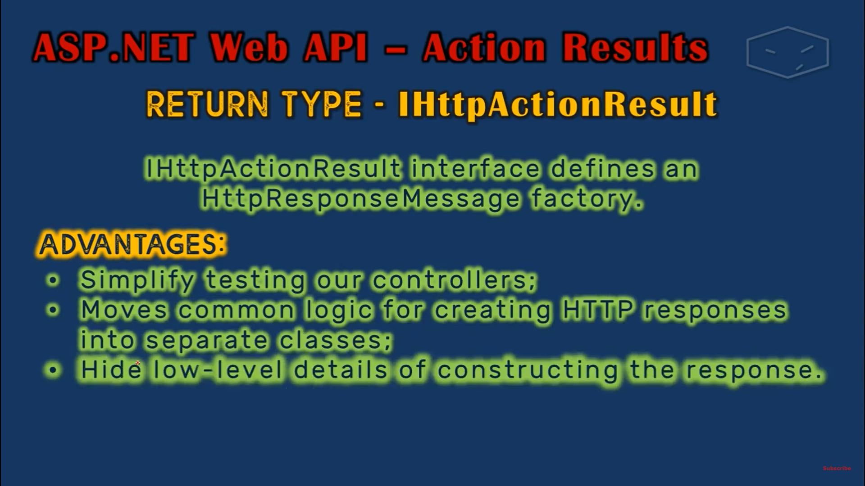

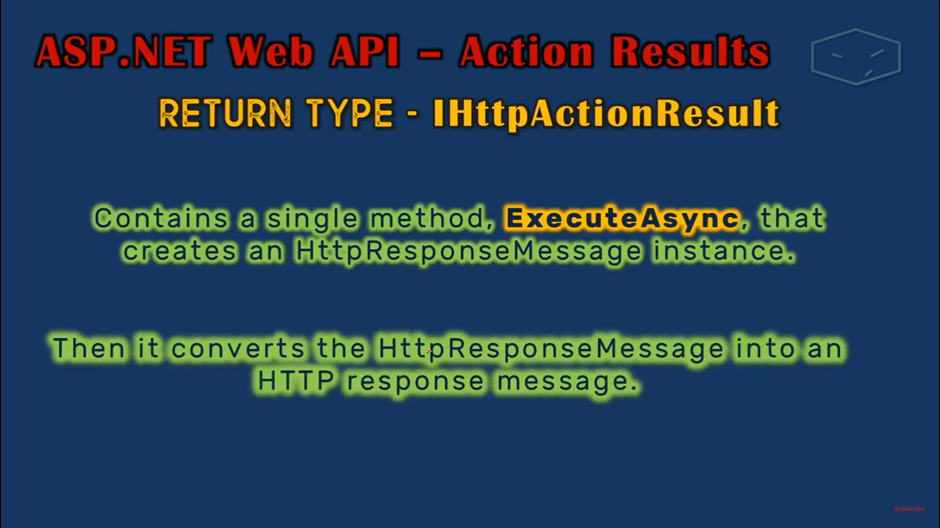

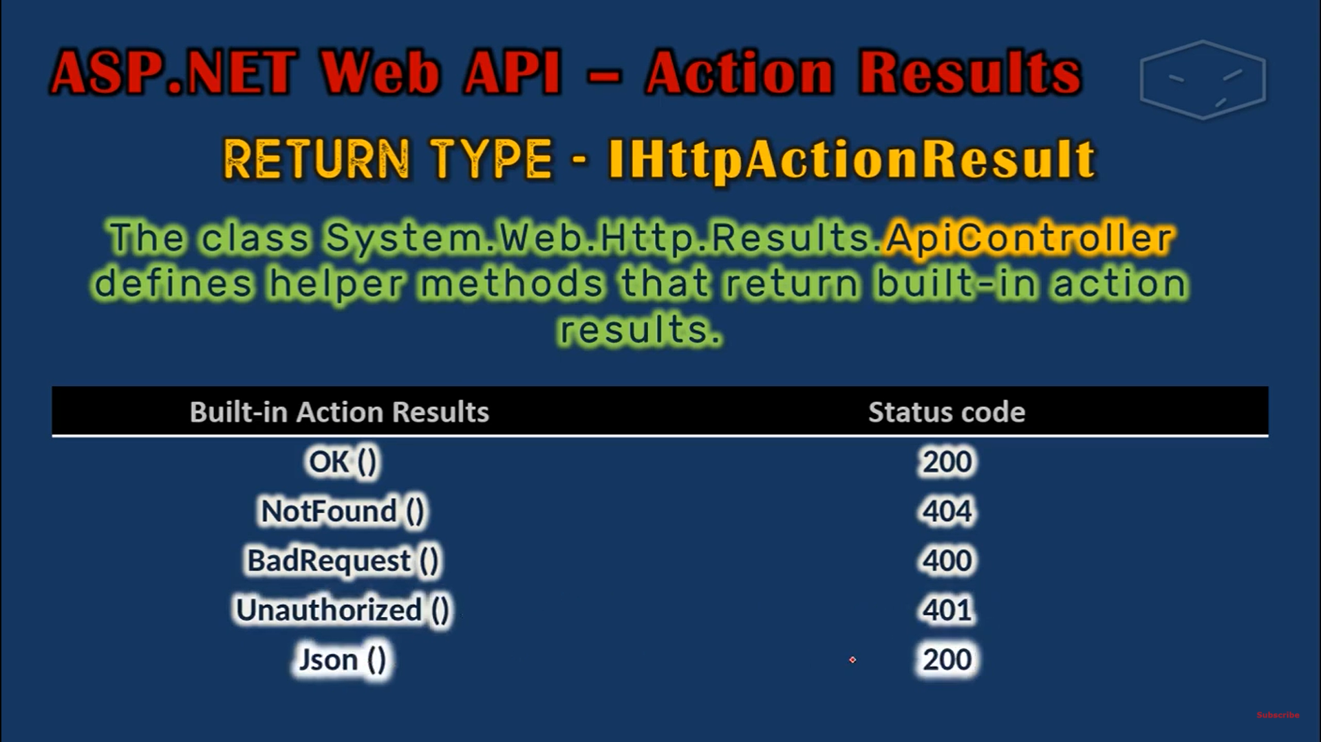

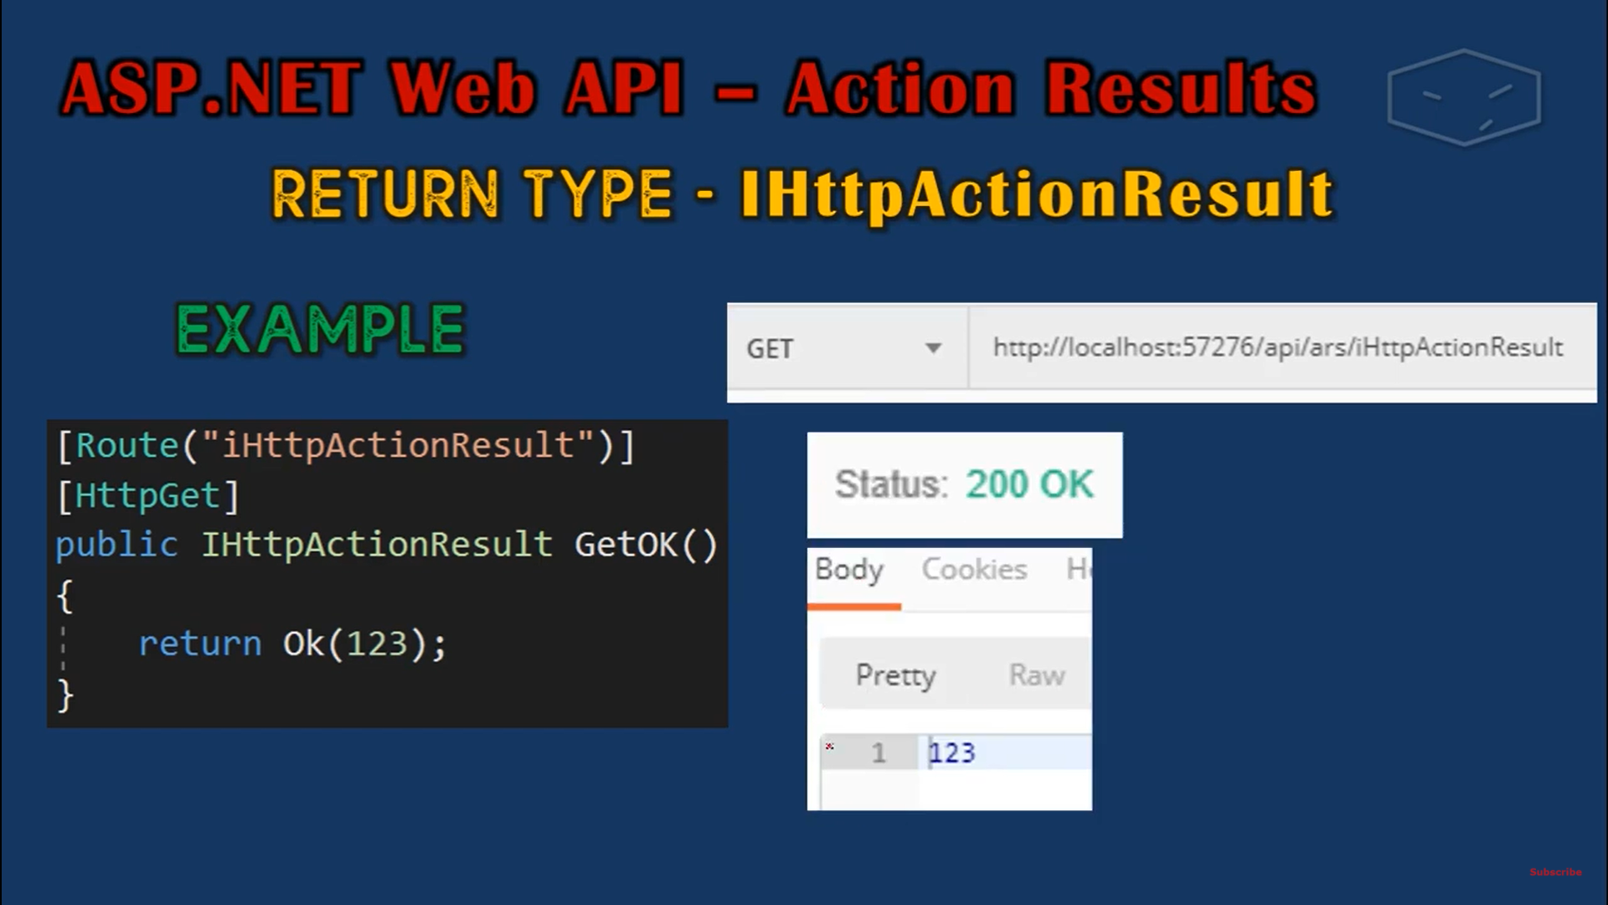

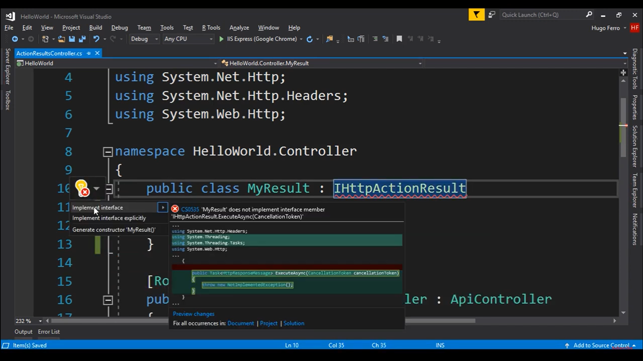

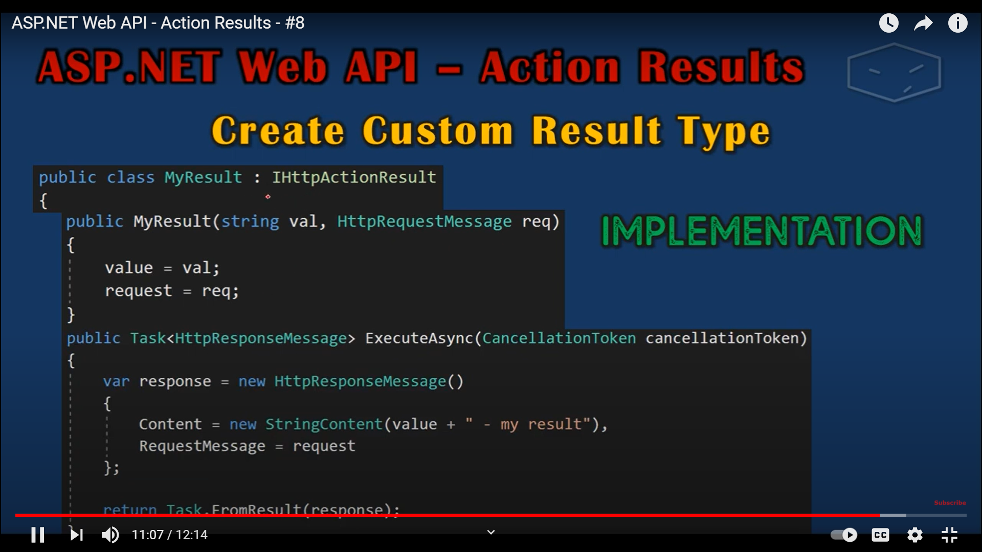

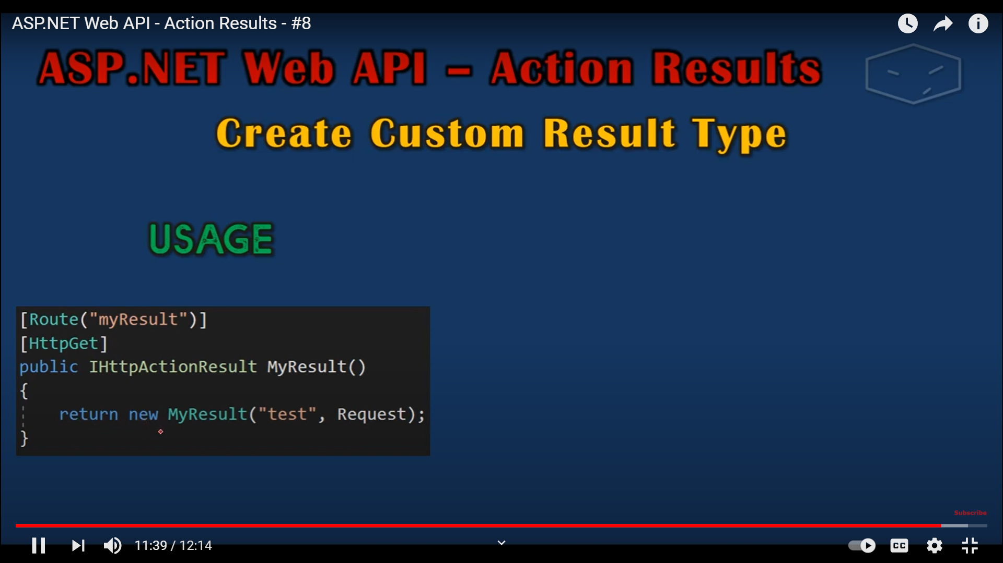

In Web Api1, we have a type called HttpResponseMessage that a controller action method can return. For ex uf we have a method wgich has ti retun list of students

Public HttpResponseMessage Get(

{

Request.CreateResponse(HttpStatusCode.OK, _strudebrList);

}

Public HttpResponseMessage Get(int id)

{if(dtusent—bull)

{

Return Request.CreateERrorResponse(httoStsyaCode.NotFounf,”Student Not found”);

Request.CreateResponse(HttpStatusCode.OK, student);

}

}

// GET: api/Students

public HttpResponseMessage Get()

{

return Request.CreateResponse(HttpStatusCode.OK, _studentList);

}

// GET: api/Students/5

public HttpResponseMessage Get(int id)

{

Student student = _studentList.FirstOrDefault(x => x.StudentId == id);

if (student == null)

return Request.CreateErrorResponse(HttpStatusCode.NotFound, "Student with this ID do not exist");

else

return Request.CreateResponse(HttpStatusCode.OK, student);

}

IN WebApi2 , we have IHTTPActionResult type

We can replace with IHTTPActionResult

Benefits?

2 Ben

1. Code becomes easy to read
2. Unit testing becomes easy

public IHttpActionResult Get()

{

return Ok(_studentList);

}

//// GET: api/Students/5

public IHttpActionResult Get(int id)

{

Student student = _studentList.FirstOrDefault(x => x.StudentId == id);

if (student == null)

return NotFound();

//

return Content( HttpStatusCode.NotFound, "Student not found");

else

return Ok(student);

}

